Current/Traditional Journey Planners Prioritise Time and Cost with no transparency of data or impact on CO2 Emmissions

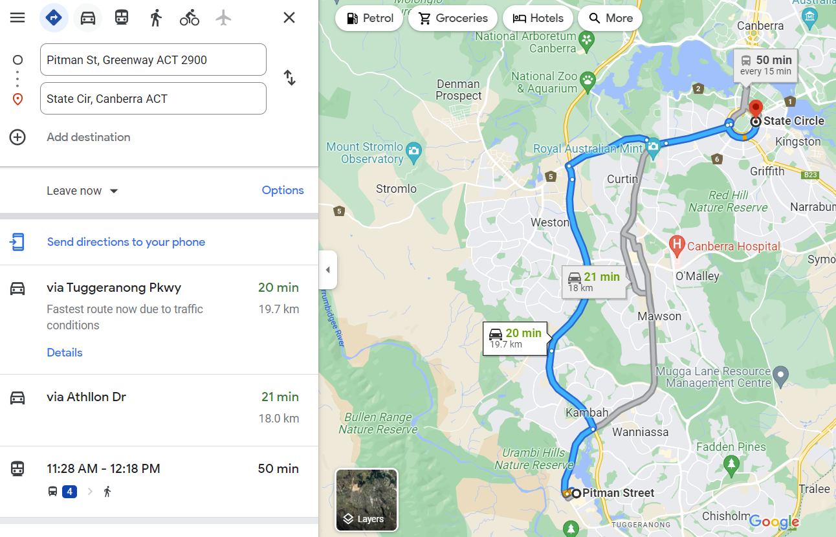

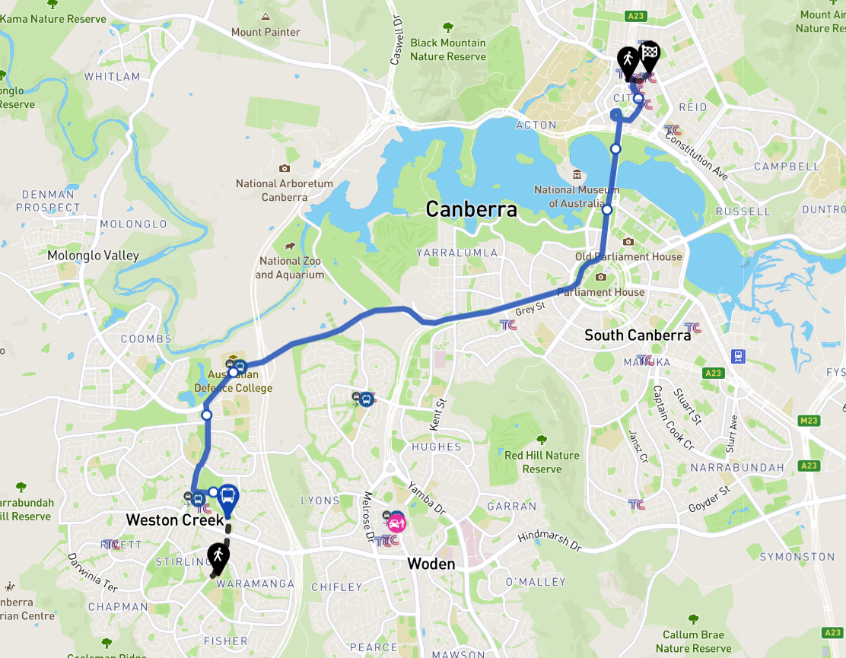

<https://www.dcceew.gov.au/climate-change/publications/national-greenhouse-gas-inventory-quarterly-update-december-2021>

<https://www.data.act.gov.au/Transport/Average-Passenger-Boardings-By-Route-2015-16-Weekd/j79z-vt4h>

<https://www.data.act.gov.au/Transport/ACTQP-HTS-Average-Trip-Distance-Categorised-by-Tra/9i94-epwn>

<https://climateactionmoreland.org/2018/03/16/carbon-emissions-and-footprint-of-different-transport-types/>

Based on using visual mediums techniques a visual representation of Impact on Carbon Footprint is an ideal way to inform decisions. This was by way of a colour coding of footprint next to traditonal route information Assist in making decisions that leave lower impacts.

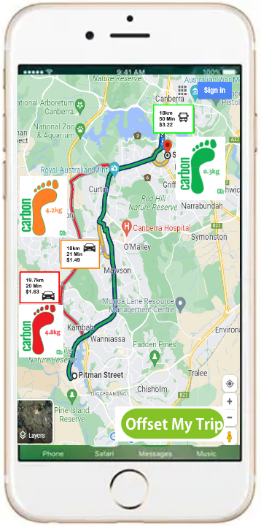

Copied footprint image from below link

<https://www.dreamstime.com/illustration/green-carbon-footprint.html>

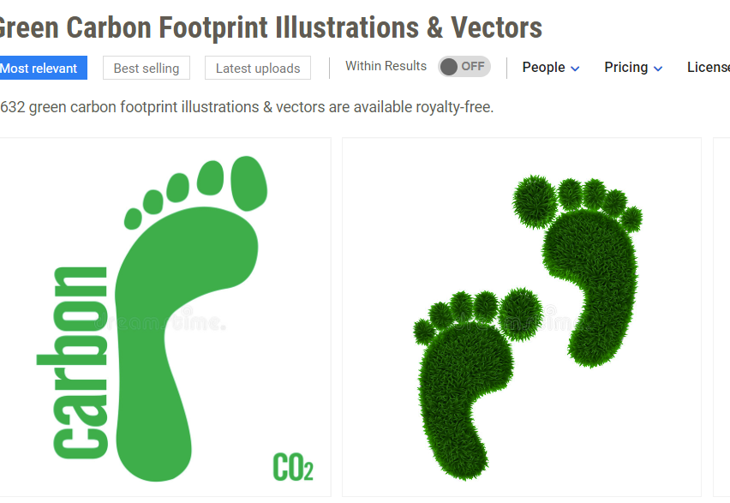

To allow individuals to choose how they offset their trip the Application utilises data from the Australian Clean Energy Regulator to allow users to support and utilise projects in their region.

The project Mapping files utilise a georeferencing algorithm to show projects in the vicinity of the trip so local projects are supported.

<https://www.cleanenergyregulator.gov.au/maps/Pages/erf-projects/index.html>

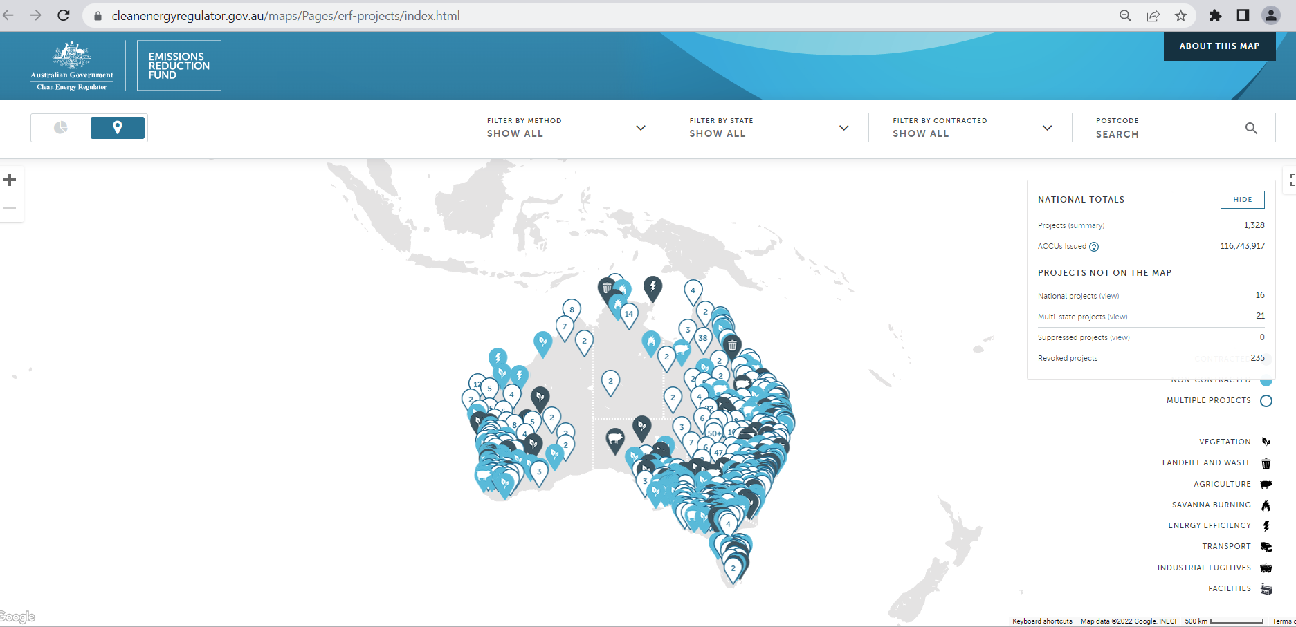

<https://www.cleanenergyregulator.gov.au/ERF/project-and-contracts-registers/project-register/project-mapping-files>

